**Compte rendu TP 1 :**

Administration de bases de données

**Travail réalisé conjointement par :**

Mohamed Aziz Bellaaj

Louay Badri

Salma Ghabri

Safa Weslati

**Groupe :** GL 4/2

1) Restore the Database and put it into the Full Recovery Model.

|  |
| --- |
| RESTORE DATABASE [AdventureWorks2014] FROM  DISK=N'C:\Users\azizb\Downloads\AdventureWorks.bak'  WITH FILE = 1, MOVE N'AdventureWorks2014_Data'  TO N'C:\Program Files\Microsoft SQL Server\MSSQL16.MSSQLSERVER\MSSQL\DATA\AdventureWorks2014_Data.mdf',  MOVE N'AdventureWorks2014_Log' TO N'C:\Program Files\Microsoft SQL Server\MSSQL16.MSSQLSERVER\MSSQL\DATA\AdventureWorks2014_Log.ldf',  NOUNLOAD,  STATS = 5;  ALTER DATABASE [AdventureWorks2014]  SET RECOVERY FULL; |

2) Back it up.

|  |
| --- |
| BACKUP DATABASE [AdventureWorks2014] TO DISK =  N'C:\Users\azizb\OneDrive - Ministere de l''Enseignement Superieur et de la Recherche Scientifique\Bureau\Projects\Database Administration\Lab 1\Backup\AdventureWorksBackup'  WITH NOFORMAT, NOINIT,  NAME = N'AdventureWorks2014-Full-Database-Backup',  SKIP, NOREWIND, NOUNLOAD, STATS = 1 |

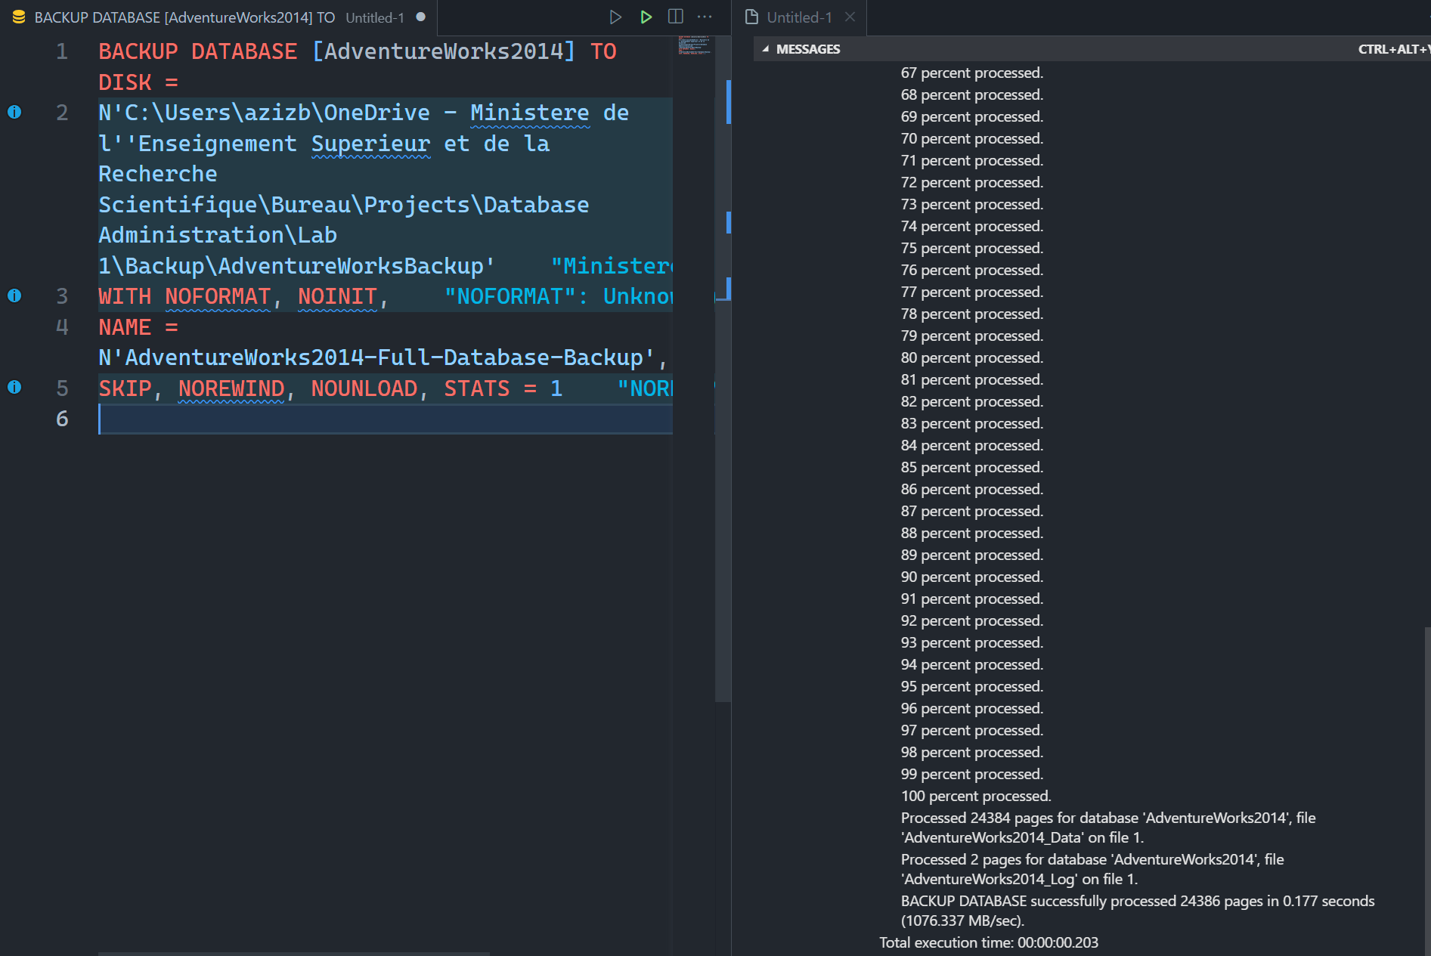

3)

|  |
| --- |
| USE [AdventureWorks2014]  GO  SELECT count(*)  FROM [Person].[Address] |

4) Add an additional row to the table [Person].[Address].

|  |
| --- |
| INSERT INTO [AdventureWorks2014].[Person].[Address]      ([AddressLine1]      ,[AddressLine2]      ,[City]      ,[StateProvinceID]      ,[PostalCode]      ,[SpatialLocation]      ,[rowguid]      ,[ModifiedDate])  VALUES      ('123 Main Street', 'Suite 456', 'Seattle', 79, '98101', NULL, NEWID(), GETDATE()); |

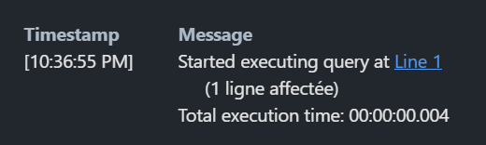

5) Return the above query.

6) Wait a couple of minutes. Note the time and write it down.

We will mark the time as 22:44:00

7) Add another additional row, as per above. Return the above query.

|  |
| --- |
| INSERT INTO [AdventureWorks2014].[Person].[Address]      ([AddressLine1]      ,[AddressLine2]      ,[City]      ,[StateProvinceID]      ,[PostalCode]      ,[SpatialLocation]      ,[rowguid]      ,[ModifiedDate])  VALUES      ('123 Secondary Street', 'Suite 123', 'Chicago', 97, '85597', NULL, NEWID(), GETDATE()); |

8) Do a Point in Time restore, to the time that you have written down.

9) Return the above query.

